Sets in Tableau

Sets are custom fields that define a subset of data based on some conditions. A set can be based on a computed condition, For example: a set may contain customers with sales over a certain threshold.

Create Dynamic Set:

The members of a dynamic set change when the underlying data changes. Dynamic sets can only be based on a single dimension.

1. **Create a Set:**

There are many ways to create a set. Create a set with specific data points, select the marks in the view and then select Create Set on the tooltip. Alternatively, right –click a dimension in the Data pane and select Create Set to create a computed set. Complete the Create Set dialog box.

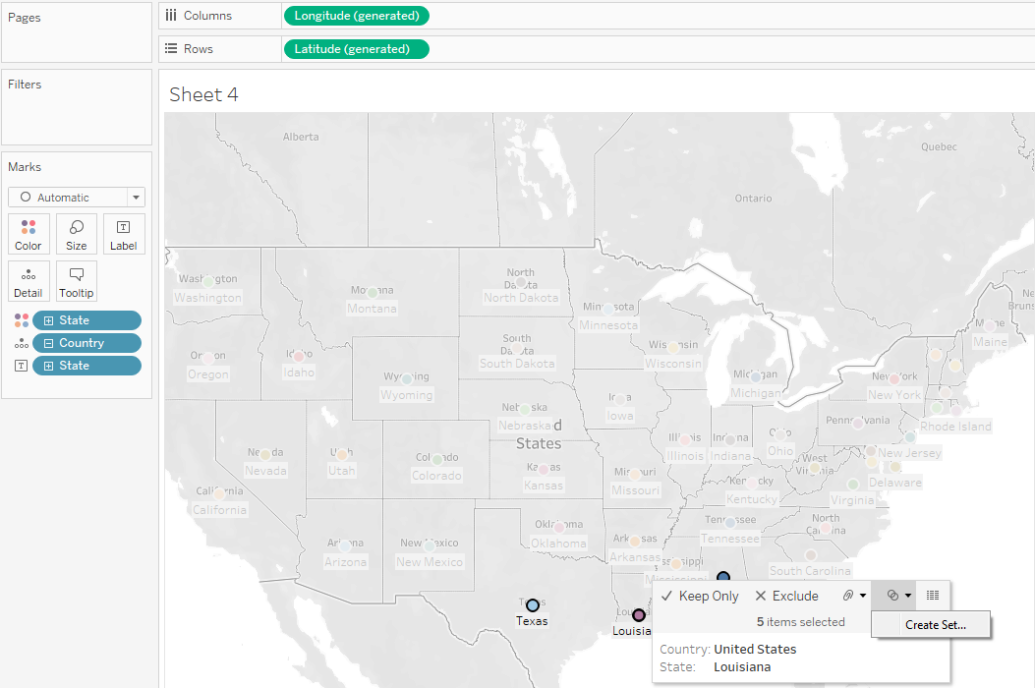

**Create Computed Set:**

The Tableau Computed Set members are dynamic and they change when the underlying data changes. In order to create Computed Set in Tableau, Please select the Dimension on which you want to create your Set and then, Right click on it will open the context menu. Please select **Create** option and then select **Set** option from the context menu as shown below

Once you select **Set** option, a new window called **Create Set** was opened to create Computed Set in tableau. We have multiple options in this window as shown below

* **Name:** Please specify the unique name for the set. Make sure, the name should reflect the set functionality.
* **General Tab:** Use this tab to select the required members from the available list.
* **Top:**This is to select all the Top and Bottom few records. For instance, Top 10 or bottom 10 records based on Profits.
* **Condition:** Used this tab to write the custom condition. For instance, Profit greater than 10000 etc.
* **All:**This select All the available members from the list
* **None:** Use this to deselect All the selected members
* **Summary:** It will display the information regarding the set. This includes Field name, Condition we used and the number of records we selected from the Total number of records etc.

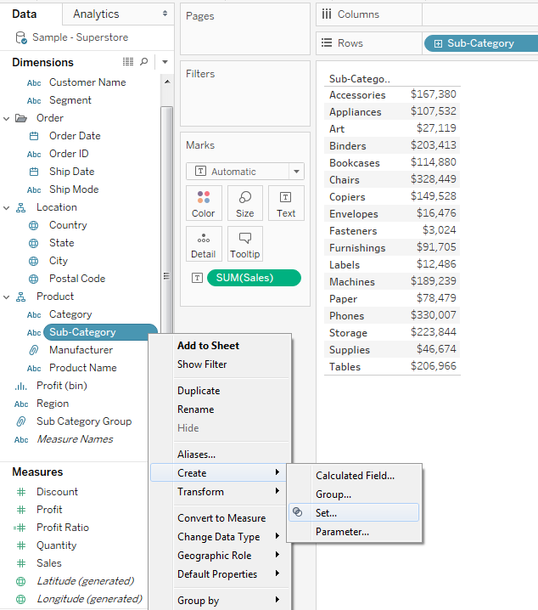

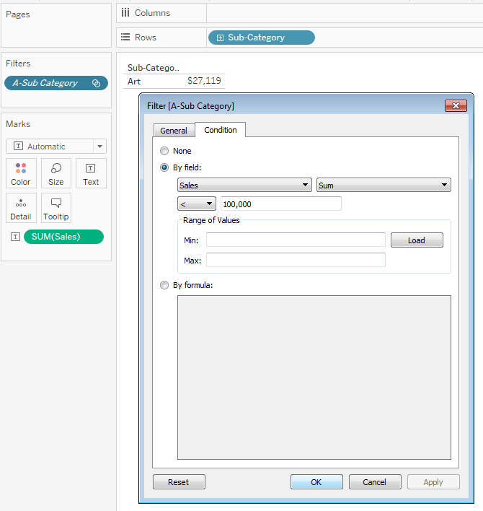

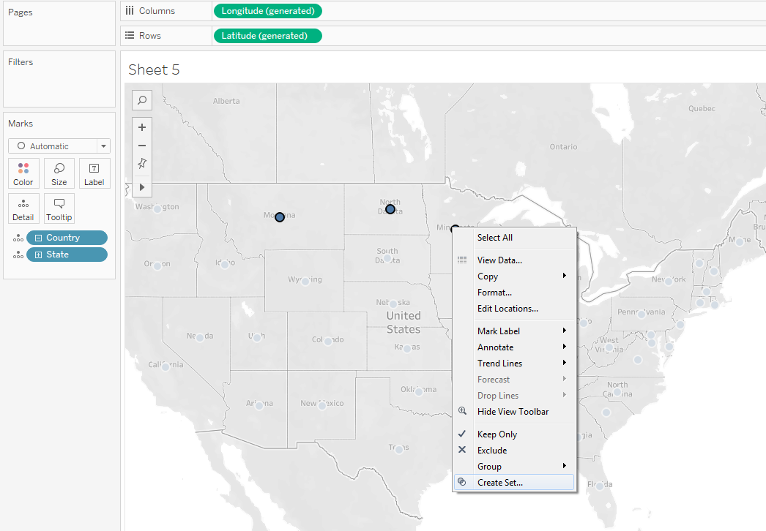

Sets in tableau can be very helpful for instance, to create Top 10 States by profit, Sales Amount greater than the minimum threshold, Products with negative profits etc.

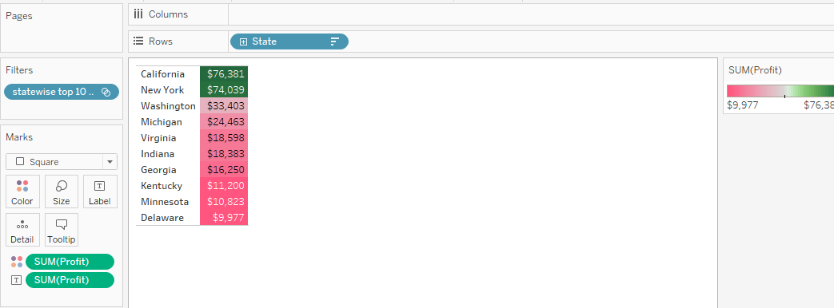

1. **Add and Remove from Sets:**

* **Name:** Please specify the unique name for the set. Make sure, the name should reflect the set functionality. For now, we named this set as **Random 10 States**
* **Members:** Members we selected in our previous step. If you want to remove any member, Please select the member value and click on the cross button
* **Add to Filters shelf:** Please check mark this option, If you want to add this set to Filters Shelf

**Create Constant Set:**

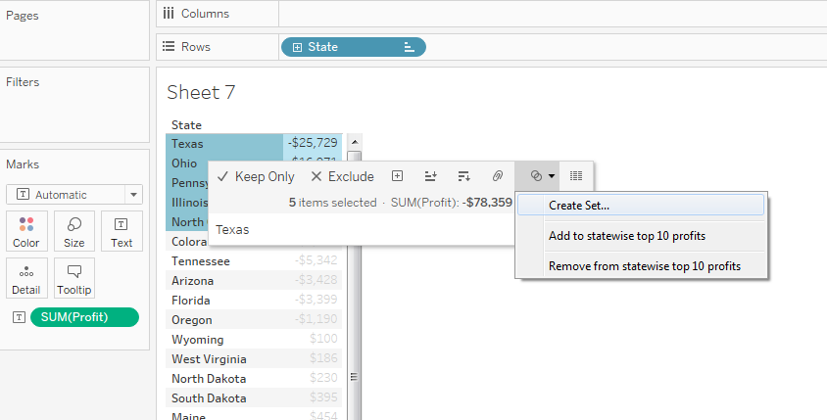

Here we have another option to remove set members from a set. Click OK to finish creating our first Tableau Set.

In: all the members we selected for creating set will be placed in In field. It means the total profit of our randomly selected 10 states.

Out: Remaining members will be placed in OUT Field.

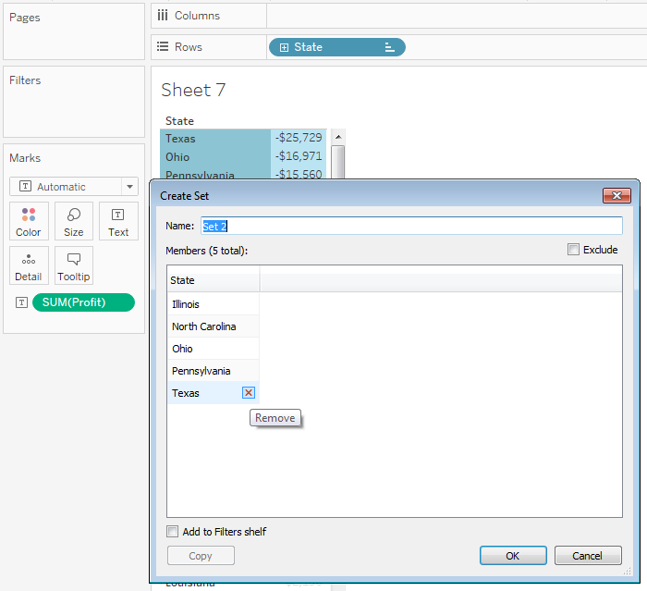

In order to show the state names (or Set members), Click on the Drop down arrow in the upper right corner of the IN/OUT (Random 10 States) member present in the **Row** Shelf and select the **Show Members in Set**option from the Drop down menu as shown below

If you want to check the States names inside the IN filed and OUT filed then Please, Drag and drop the newly created set (Random 10 Products) from Sets region to **Row** Shelf. Next, drag and drop the State filed from dimension region to **Row** Shelf.

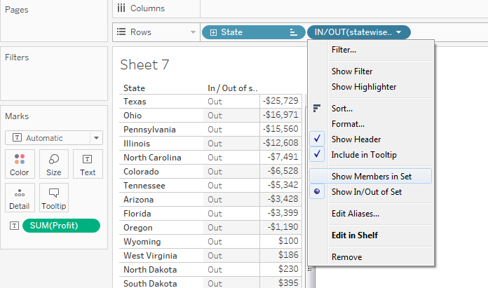

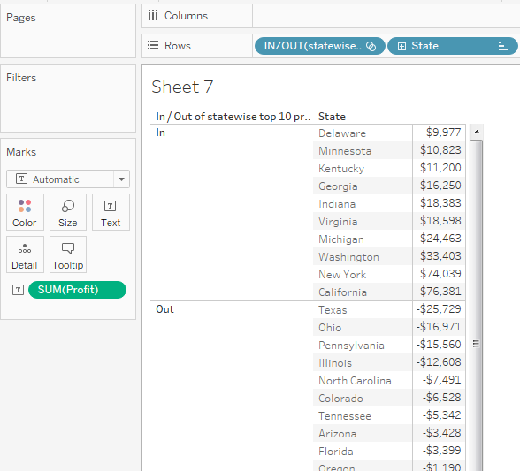

**Create Combined Set:**

By using combine set option we can combine two set or we can compare two members. To compare the two sets they must be from same dimension.

**Steps to create Combine Set:**

1. Select two sets in the Data pane that you want to combine.

2. Right-click (control-click on Mac) the sets and select **Create Combined Set**.

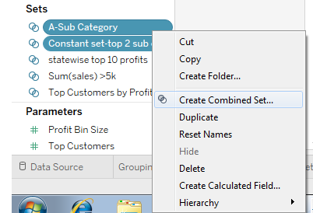

3.In the Create Set dialog box, type a name for the new combined set.

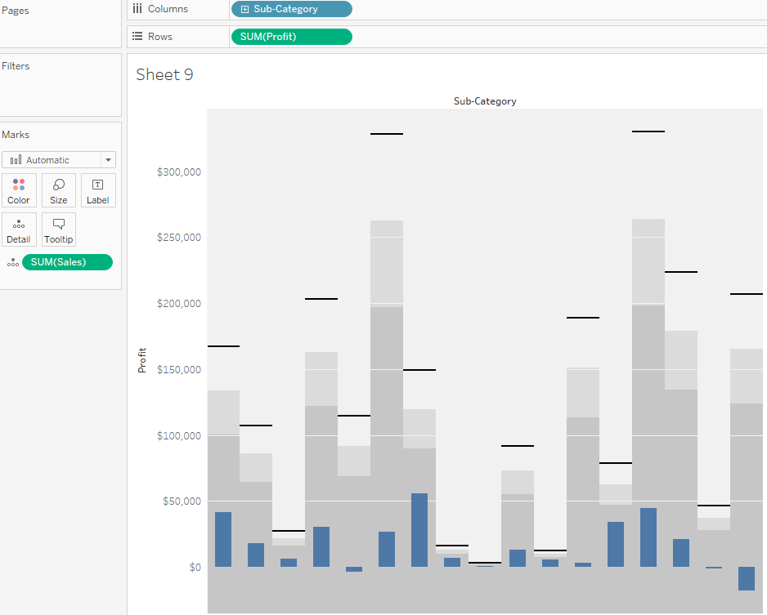

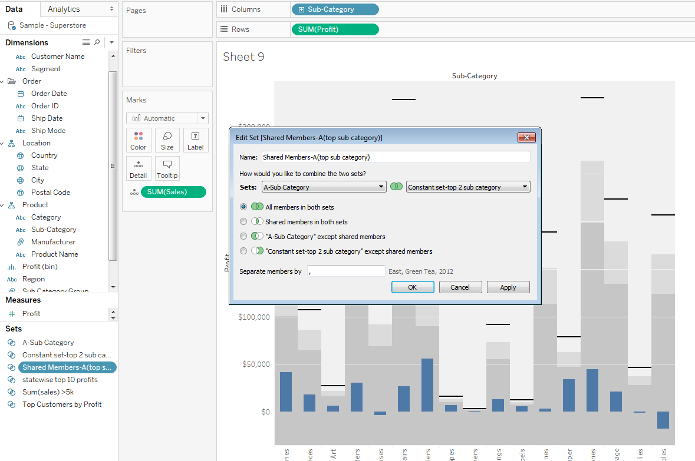

4. Verify that the two sets you want to combine are selected in the two drop-down menus.

5. Select one of the following options for how to combine the sets:

**a. All Members in Both Sets**- the combined set will contain all of the members from both sets.

**b. Shared Members in Both Sets**- the combined set will only contain members that exist in both sets.

**c. Except Shared Members**- the combined set will contain all members from the specified set that don't exist in the second set. These options are equivalent to subtracting one set from another.

6. Optionally specify a character that will separate the members if the sets represent multiple dimensions.

7. When finished, click **OK**.

